SpringBoot整合 jsp

创建项目并添加依赖
<project xmlns="http://maven.apache.org/POM/4.0.0" xmlns:xsi="http://www.w3.org/2001/XMLSchema-instance"
xsi:schemaLocation="http://maven.apache.org/POM/4.0.0 http://maven.apache.org/xsd/maven-4.0.0.xsd">
<modelVersion>4.0.0</modelVersion>
<parent>
<groupId>org.springframework.boot</groupId>
<artifactId>spring-boot-starter-parent</artifactId>
<version>1.5.17.RELEASE</version>
</parent>
<groupId>com.sxt</groupId>
<artifactId>08-spring-boot-view-jsp</artifactId>
<version>0.0.1-SNAPSHOT</version>
<properties>
<java.version>1.8</java.version>
</properties>
<dependencies>
<!-- springBoot 的启动器 -->
<dependency>
<groupId>org.springframework.boot</groupId>
<artifactId>spring-boot-starter-web</artifactId>
</dependency>
<!-- jstl -->
<dependency>
<groupId>javax.servlet</groupId>
<artifactId>jstl</artifactId>
</dependency>
<!-- jasper -->
<dependency>
<groupId>org.apache.tomcat.embed</groupId>
<artifactId>tomcat-embed-jasper</artifactId>
<scope>provided</scope>
</dependency>
</dependencies>
</project>

创建 springBoot的全局配置文件，application.properties
spring.mvc.view.prefix=/WEB-INF/jsp/
spring.mvc.view.suffix=.jsp

创建 Controller
/**
* SpringBoot 整合 jsp
*/
@Controller
public class UserController {
/*
* 处理请求，产生数据
*/
@RequestMapping("/showUser")
public String showUser(Model model) {
List<User> list = new ArrayList<>();
list.add(new User(1, "张三", 20));
list.add(new User(2, "李四", 22));
list.add(new User(3, "王五", 24));
// 需要一个 Model 对象
model.addAttribute("list", list);
// 跳转视图
return "userList";
}
}

创建 jsp
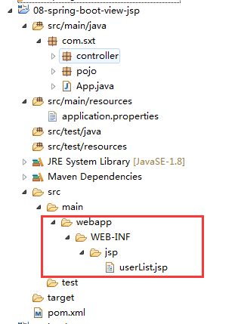
<%@ page language="java" contentType="text/html; charset=UTF-8"
pageEncoding="UTF-8"%>
<%@ taglib uri="http://java.sun.com/jsp/jstl/core" prefix="c"%>
<!DOCTYPE html PUBLIC "-//W3C//DTD HTML 4.01 Transitional//EN" "http://www.w3.org/TR/html4/loose.dtd">
<html>
<head>
<meta http-equiv="Content-Type" content="text/html; charset=UTF-8">
<title>Insert title here</title>
</head>
<body>
<table border="1" align="center" width="50%">
<tr>
<th>ID</th>
<th>Name</th>
<th>Age</th>
</tr>
<c:forEach items="${list }" var="user">
<tr>
<td>${user.userid }</td>
<td>${user.username }</td>
<td>${user.userage }</td>
</tr>
</c:forEach>
</table>
</body>
</html>

创建启动类
/**
* SpringBoot 启动类
*/
@SpringBootApplication
public class App {
public static void main(String[] args) {
SpringApplication.run(App.class, args);
}
}

